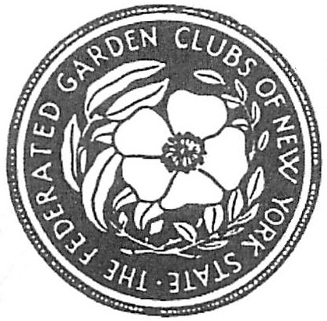

FEDERATED GARDEN CLUBS OF NEW YORK STATE, INC
AWARDS APPLICATION 2015-2017
Award Name: Number (if applicable):

Submitted by:
(Enter name exactly as it should appear on any award received)
Name of Garden Club: Number in Garden Club:
Mailing Address of Garden Club:

District Awards Chairman: Phone: Email:
State Awards Chairman: Phone: Email:

- Application form is limited to three printed pages, front of pages only. (No report cover or binders allowed,
No plastic sheets allowed)
- Application form will not be returned. (Exceptions: publication (books), CD/DVD). Copy entry for your files.
- Deadlines for sending to District Chairman:
Publicity/Press Books January 25 to State Chairman
Award of Honor to State Chairman by January 15th
District Awards Chairman October 1st
State Awards Chairman November 1st
Flower Shows held after October 15 deadline is Dec 15th
Check other dates for youth awards
Please complete each topic, if applicable. Use numbering as below when completing form.
1. New Project: Yes_____ No______ Beginning date: Completion date:
2. Brief summary and objectives of project:
3. Involvement of club members, other organizations, etc.
4. Project expenses and means of funding:
5. Continuing involvement, follow-up, maintenance:
6. Attach or insert photos, digital photos, and/or landscape plan does not need to be professionally drawn).

